WampServer

🌟 Definition
# Source: AI Source: Provided by: [Data Path: Persons Table -> ID Column: 1, Name_En Column: Motasem Essam] -> From: [ChatGPT] on [6/1/2026]
WampServer is a local web development environment for Windows that allows developers to build, test, and run websites, web applications, databases, and APIs on their own computer without needing an online server.
Official website:
WampServer

🧩 What does WAMP mean?
# Source: AI Source: Provided by: [Data Path: Persons Table -> ID Column: 1, Name_En Column: Motasem Essam] -> From: [ChatGPT] on [6/1/2026]
WAMP =
- W → Windows
- A → Apache (Web Server)
- M → MySQL / MariaDB (Database System)
- P → PHP (Programming Language)

🎯 Purpose
# Source: AI Source: Provided by: [Data Path: Persons Table -> ID Column: 1, Name_En Column: Motasem Essam] -> From: [ChatGPT] on [6/1/2026]
- Develop PHP websites locally
- Test web applications before deployment
- Create and manage databases
- Build and test REST APIs
- Learn web development safely

📚 Main Components

1. Apache
# Source: AI Source: Provided by: [Data Path: Persons Table -> ID Column: 1, Name_En Column: Motasem Essam] -> From: [ChatGPT] on [6/1/2026]
🌟 Web Server
Purpose:
- Hosts websites locally
- Handles HTTP requests
Example URL:
http://localhost/

2. MySQL / MariaDB
# Source: AI Source: Provided by: [Data Path: Persons Table -> ID Column: 1, Name_En Column: Motasem Essam] -> From: [ChatGPT] on [6/1/2026]
🌟 Database Management System
Purpose:
- Store application data
- Manage users, products, orders, etc.
Example SQL:
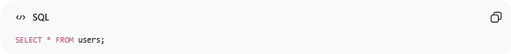
SELECT * FROM users;

3. PHP
# Source: AI Source: Provided by: [Data Path: Persons Table -> ID Column: 1, Name_En Column: Motasem Essam] -> From: [ChatGPT] on [6/1/2026]
🌟 Server-Side Programming Language
Purpose:
- Create dynamic websites
- Process forms
- Build APIs
Example:
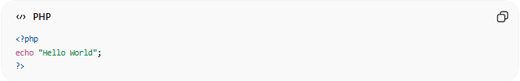
<?php
echo "Hello World";
?>

4. phpMyAdmin
# Source: AI Source: Provided by: [Data Path: Persons Table -> ID Column: 1, Name_En Column: Motasem Essam] -> From: [ChatGPT] on [6/1/2026]
🌟 Database Administration Tool
Purpose:
- Create databases
- Manage tables
- Execute SQL queries
Access:
http://localhost/phpmyadmin

🔗 How WampServer Works
# Source: AI Source: Provided by: [Data Path: Persons Table -> ID Column: 1, Name_En Column: Motasem Essam] -> From: [ChatGPT] on [6/1/2026]
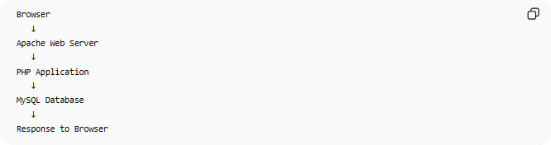
Browser
↓
Apache Web Server
↓
PHP Application
↓
MySQL Database
↓
Response to Browser

📂 Typical Project Structure
# Source: AI Source: Provided by: [Data Path: Persons Table -> ID Column: 1, Name_En Column: Motasem Essam] -> From: [ChatGPT] on [6/1/2026]
Projects are usually stored in:
C:\wamp64\www\
Example:
C:\wamp64\www\myproject\
Access in browser:
http://localhost/myproject/

🛠 Common Uses
# Source: AI Source: Provided by: [Data Path: Persons Table -> ID Column: 1, Name_En Column: Motasem Essam] -> From: [ChatGPT] on [6/1/2026]
Website Development
- PHP websites
- WordPress websites
API Development
- REST APIs
- JSON APIs
Database Learning
- SQL practice
- Database design
Education
- Learning PHP and MySQL

⚙️ WampServer Control Panel
# Source: AI Source: Provided by: [Data Path: Persons Table -> ID Column: 1, Name_En Column: Motasem Essam] -> From: [ChatGPT] on [6/1/2026]
The WampServer tray icon allows you to:
- Start Apache
- Stop Apache
- Restart Apache
- Start MySQL
- Stop MySQL
- Access phpMyAdmin
- Manage PHP versions

⚖️ WampServer vs XAMPP
# Source: AI Source: Provided by: [Data Path: Persons Table -> ID Column: 1, Name_En Column: Motasem Essam] -> From: [ChatGPT] on [6/1/2026]
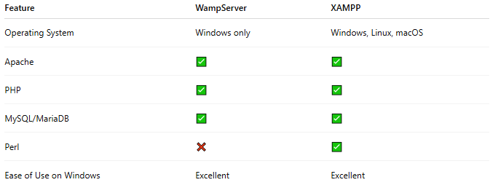
Feature | WampServer | XAMPP
Operating System | Windows only | Windows, Linux, macOS
Apache | ✅ | ✅
PHP | ✅ | ✅
MySQL/MariaDB | ✅ | ✅
Perl | ❌ | ✅
Ease of Use on Windows | Excellent | Excellent

🧠 Where WampServer Belongs
# Source: AI Source: Provided by: [Data Path: Persons Table -> ID Column: 1, Name_En Column: Motasem Essam] -> From: [ChatGPT] on [6/1/2026]
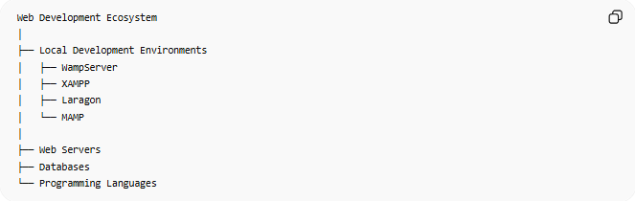
Web Development Ecosystem
│
├── Local Development Environments
│ ├── WampServer
│ ├── XAMPP
│ ├── Laragon
│ └── MAMP
│
├── Web Servers
├── Databases
└── Programming Languages

Download WampServer
# Source: ScreenShot Source: Provided by: [Persons Table -> ID Column: 1, Name_En Column: Motasem Essam] -> Tool: [Automation Table -> ID Column: 16, Name_En Column: Screen Capture] -> From [Site: Google Search: All: WampServer] on [6/1/2025]
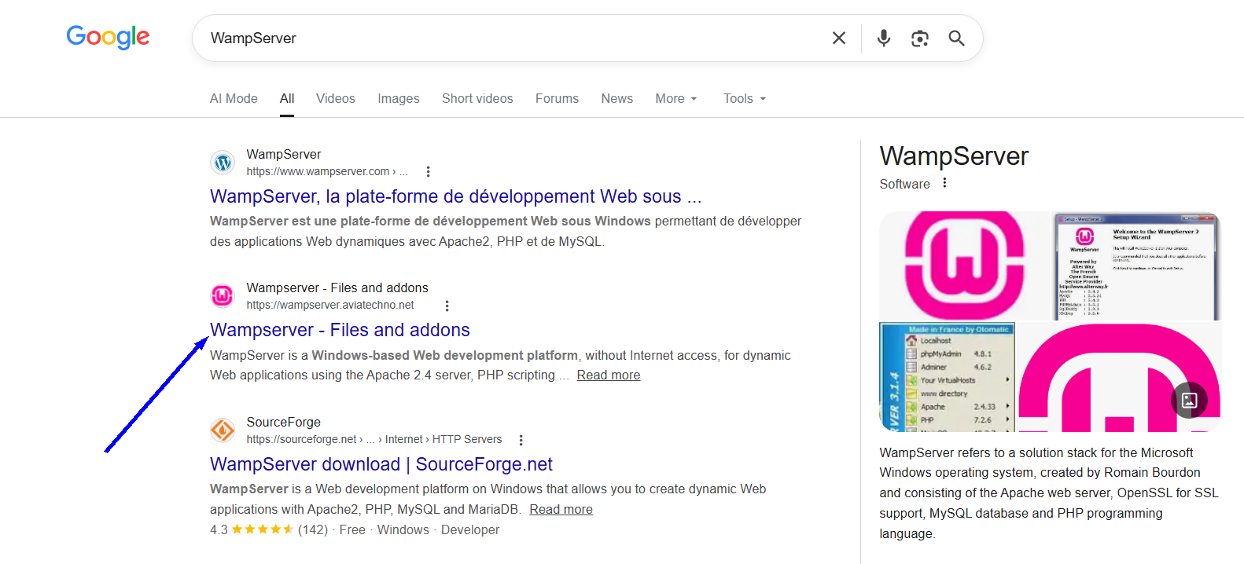
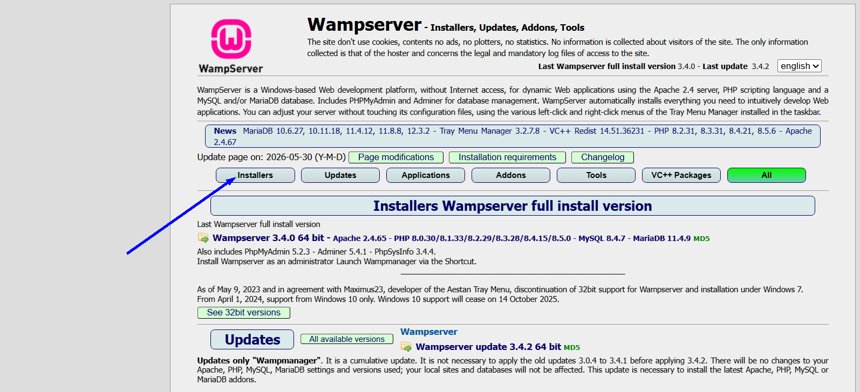
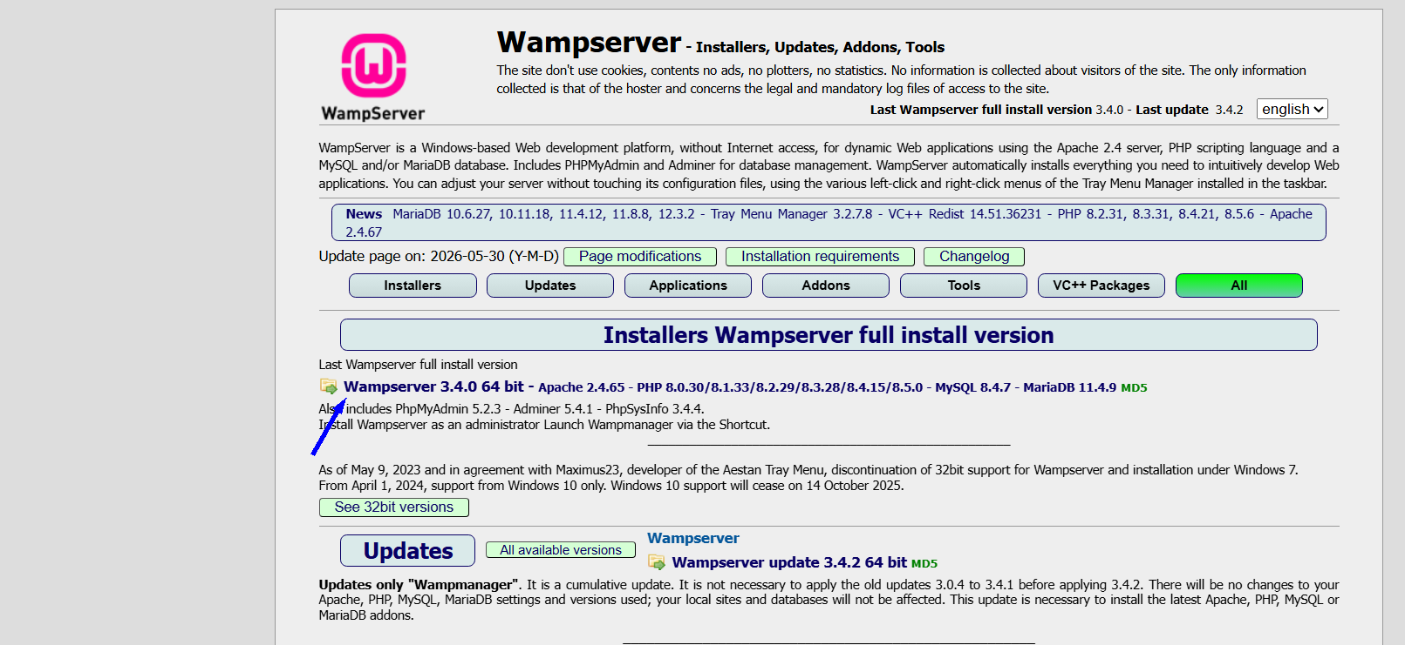

Install WampServer
# Source: ScreenShot Source: Provided by: [Persons Table -> ID Column: 1, Name_En Column: Motasem Essam] -> Tool: [Automation Table -> ID Column: 16, Name_En Column: Screen Capture] -> From [Operating System: Windows] on [6/1/2026]
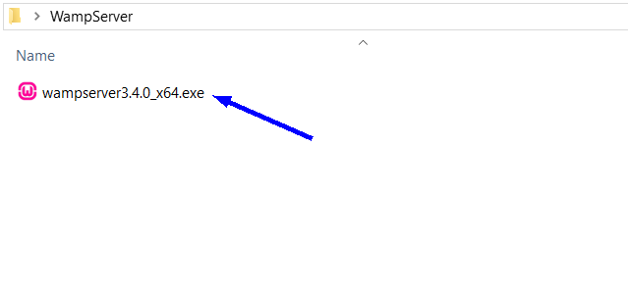
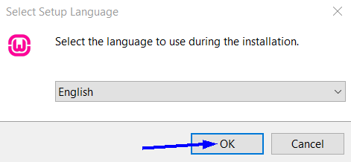
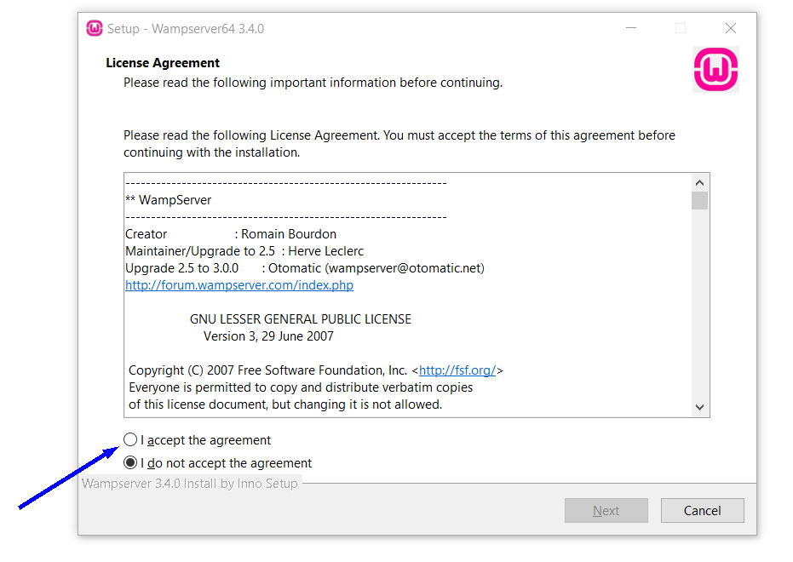
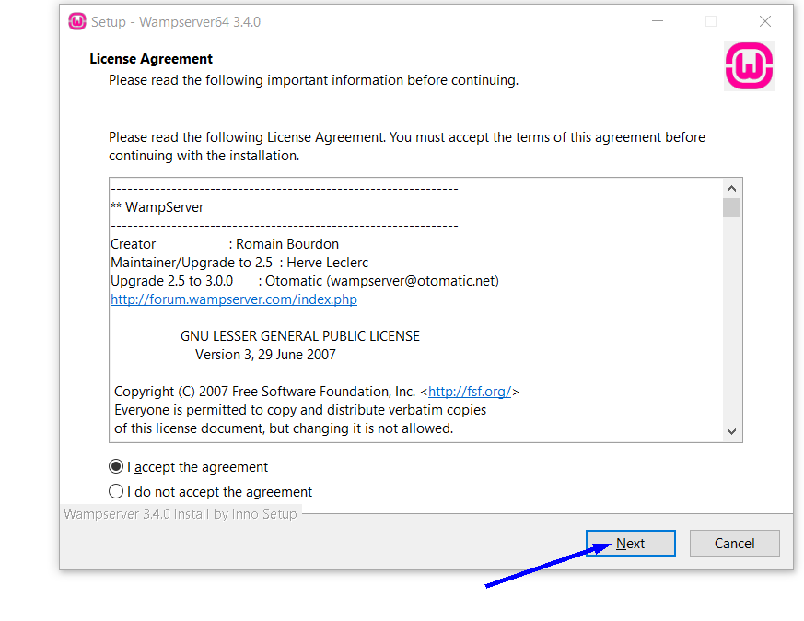
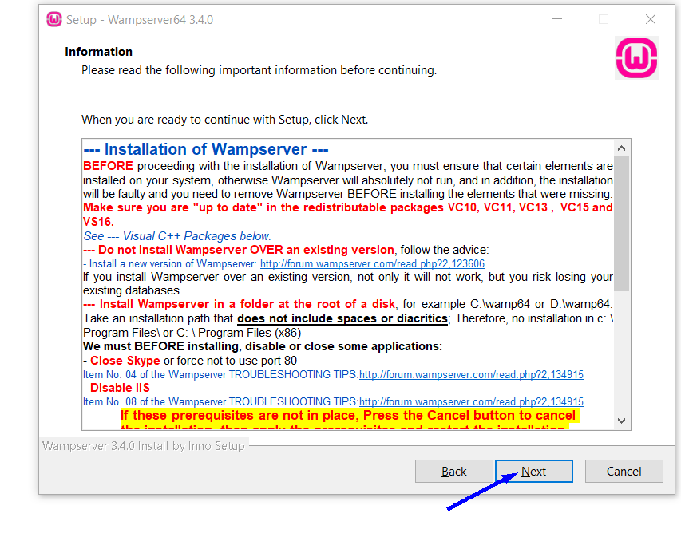
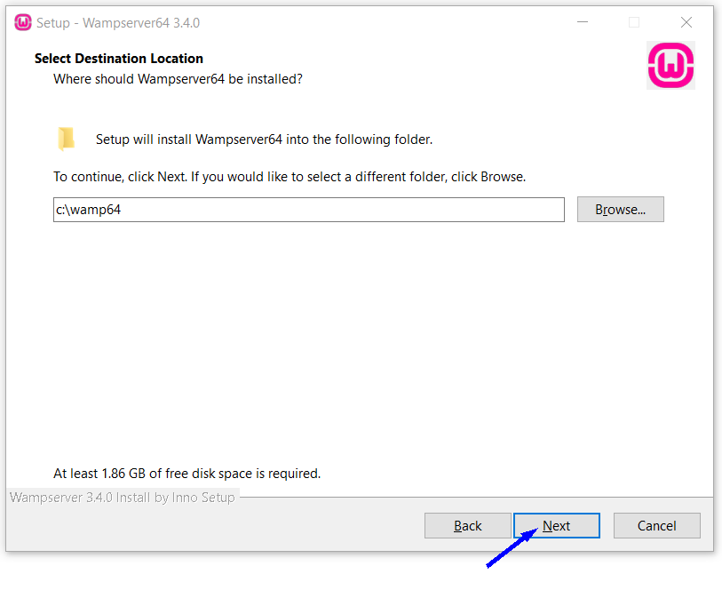
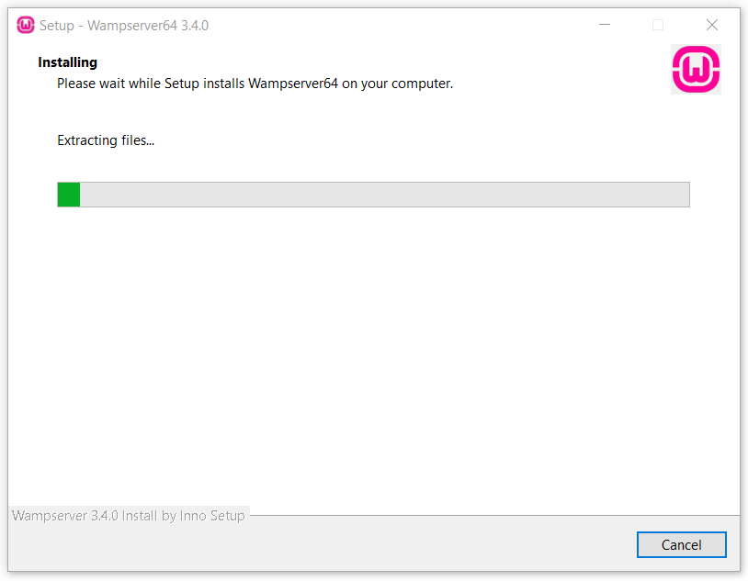
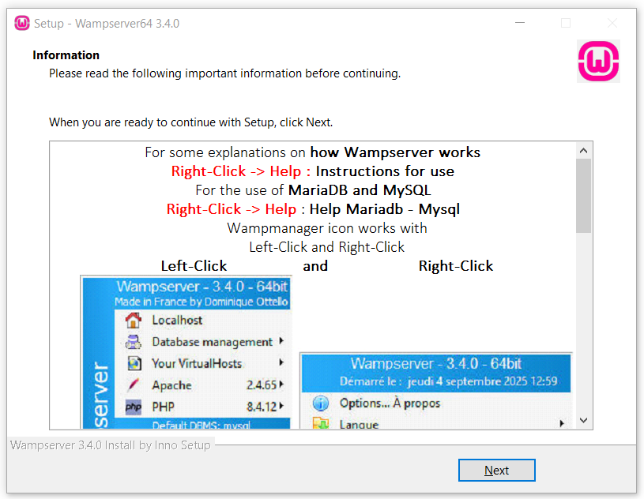
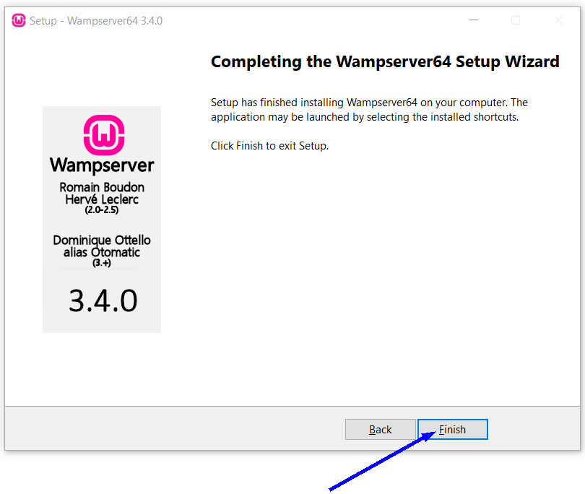

Run WampServer
# Source: ScreenShot Source: Provided by: [Persons Table -> ID Column: 1, Name_En Column: Motasem Essam] -> Tool: [Automation Table -> ID Column: 16, Name_En Column: Screen Capture] -> From [Operating System: Windows] on [6/1/2026]
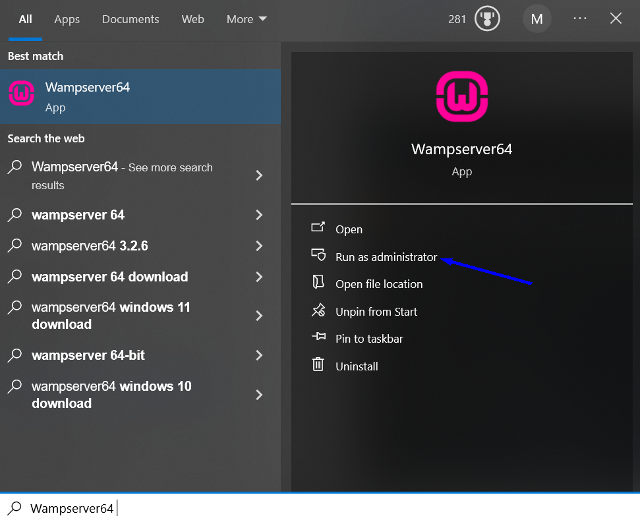
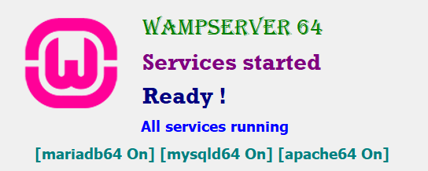

Open Localhost
# Source: ScreenShot Source: Provided by: [Persons Table -> ID Column: 1, Name_En Column: Motasem Essam] -> Tool: [Automation Table -> ID Column: 16, Name_En Column: Screen Capture] -> From [Operating System: Windows] on [6/1/2026]
Right click
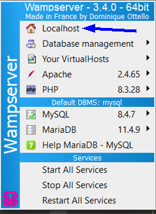
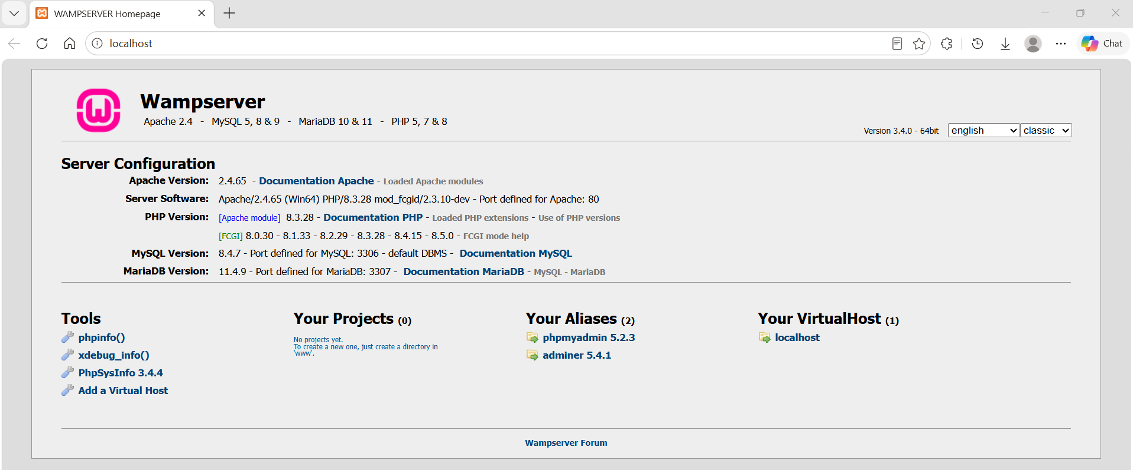
http://localhost/

Open phpMyAdmin
# Source: ScreenShot Source: Provided by: [Persons Table -> ID Column: 1, Name_En Column: Motasem Essam] -> Tool: [Automation Table -> ID Column: 16, Name_En Column: Screen Capture] -> From [Operating System: Windows] on [6/1/2026]
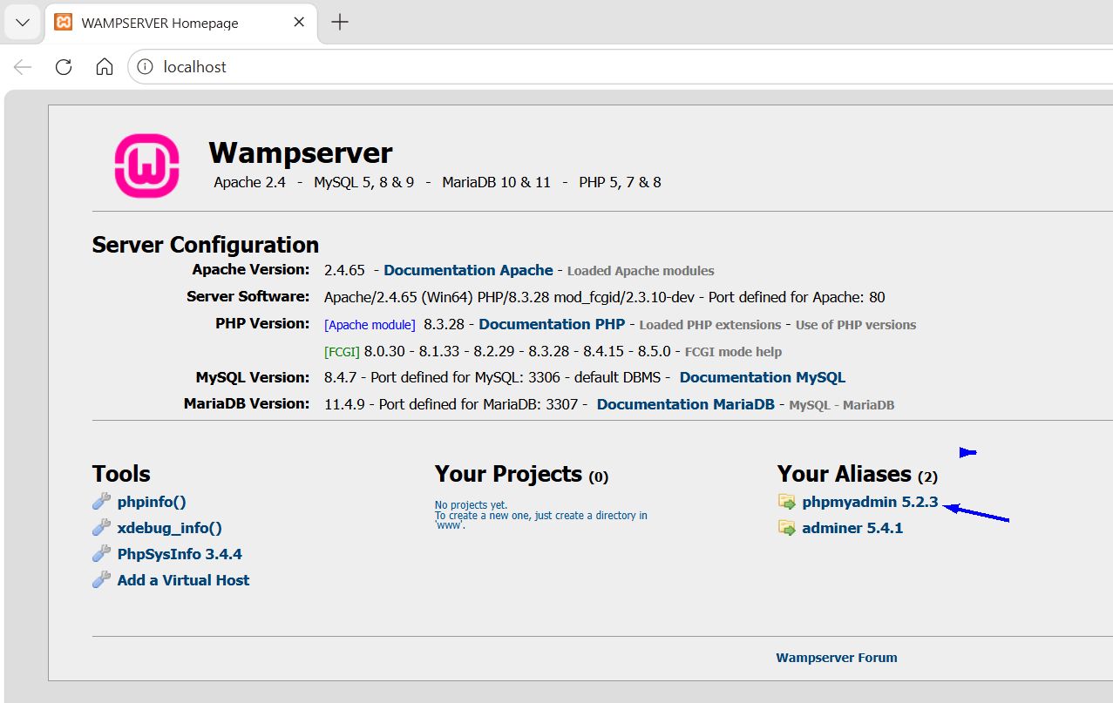
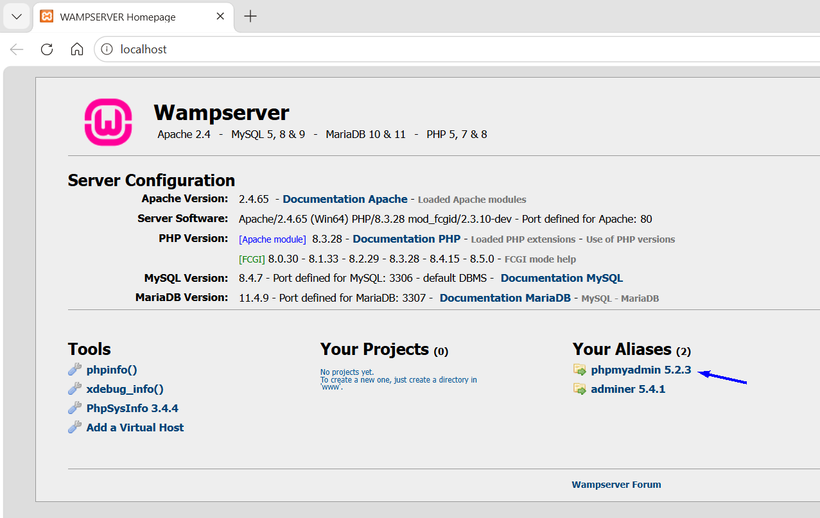
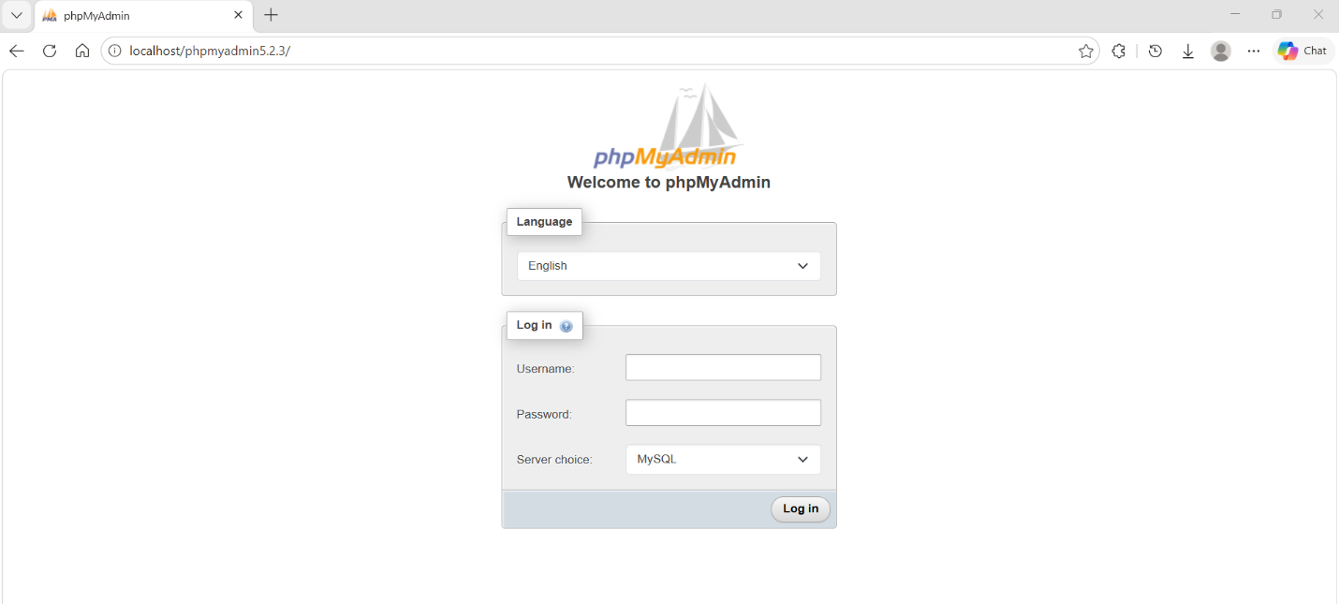
http://localhost/phpmyadmin5.2.3/
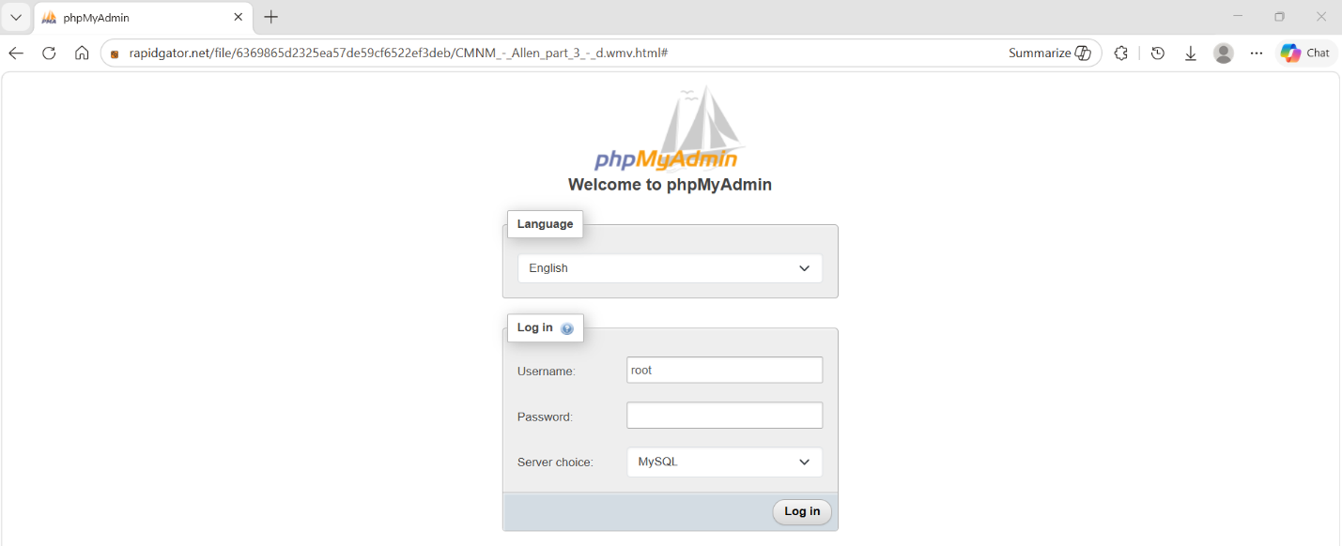
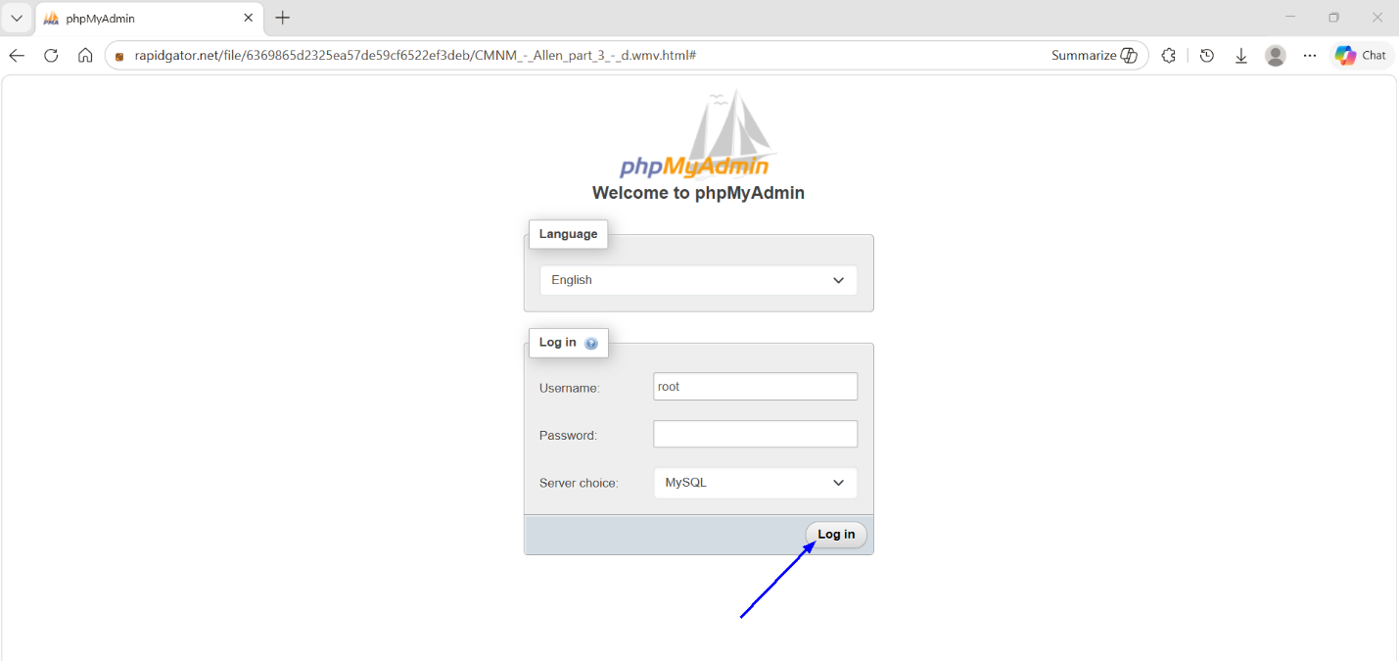
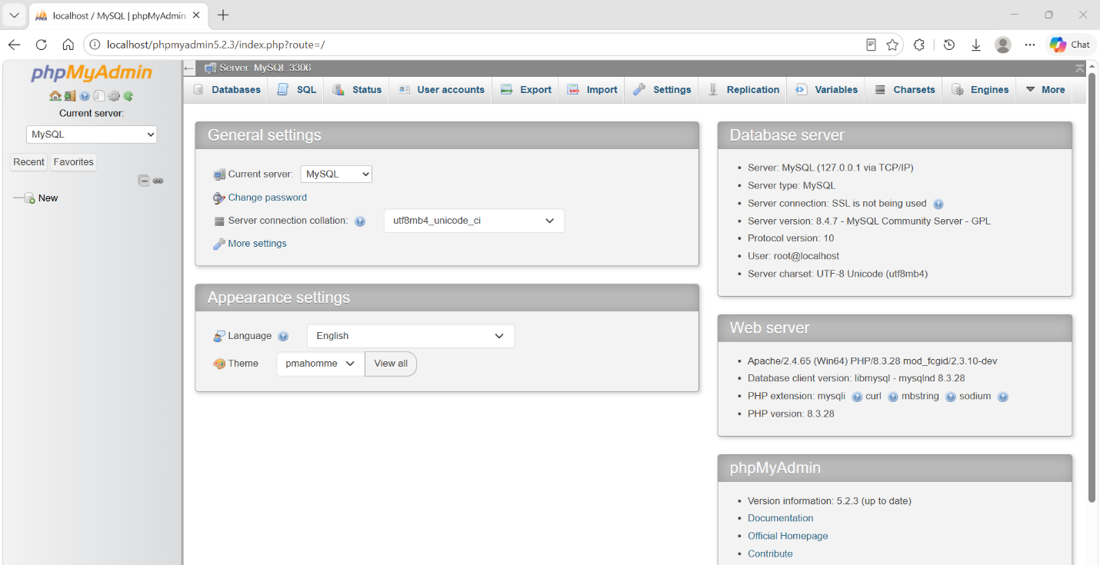

Create a Project Folder
# Source: ScreenShot Source: Provided by: [Persons Table -> ID Column: 1, Name_En Column: Motasem Essam] -> Tool: [Automation Table -> ID Column: 16, Name_En Column: Screen Capture] -> From [Operating System: Windows] on [6/1/2026]
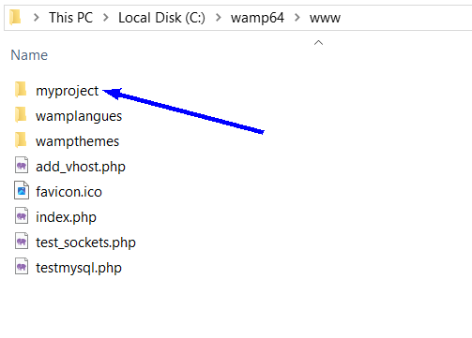

Create index.php
# Source: ScreenShot Source: Provided by: [Persons Table -> ID Column: 1, Name_En Column: Motasem Essam] -> Tool: [Automation Table -> ID Column: 16, Name_En Column: Screen Capture] -> From [Operating System: Windows] on [6/1/2026]
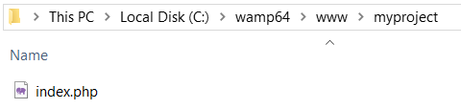
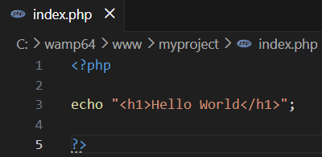
<?php

echo "<h1>Hello World</h1>";

?>

Open index.php
# Source: ScreenShot Source: Provided by: [Persons Table -> ID Column: 1, Name_En Column: Motasem Essam] -> Tool: [Automation Table -> ID Column: 16, Name_En Column: Screen Capture] -> From [Operating System: Windows] on [6/1/2026]
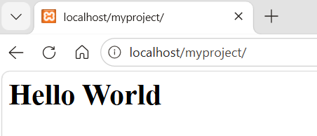
http://localhost/myproject/

🧭 Summary
# Source: AI Source: Provided by: [Data Path: Persons Table -> ID Column: 1, Name_En Column: Motasem Essam] -> From: [ChatGPT] on [6/1/2026]
WampServer is a Windows-based local development environment that bundles Apache, PHP, MySQL/MariaDB, and phpMyAdmin, allowing developers to create, test, and run websites, databases, and APIs on their own computer before deploying them to a live server.

